ТМ-9 part 2
Determine velocity v₁ and acceleration a₁ of body 1 of the given mechanical system (fig. 1) when translation of body 1 is equal to x₁ = 1 m. It is known that masses of bodies are m₁ = 10 kg, m₂ = 20 kg, m₃ = 30 kg, respectively. External radius of body 2 is R₂ = 1 m, internal radius of body 2 is r₂ = 0.5 m, and a radius of body 3 is R₃ = 0.75 m. Radii of inertia of bodies 2 and 3 are i₂ = i₃ = 0.75 m. Coefficient of friction of body 1 is f = 0.1, moment of force M₂ = 10 N·m, force F = 50 N, and angle α = 45°. The mechanical system is in equilibrium at the moment of time t₀ = 0, friction of strings on pulleys can be neglected.
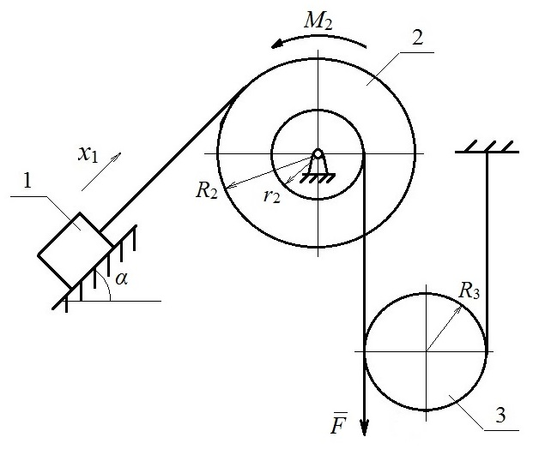
Fig. 1 Initial scheme

Solution
Given:  x₁ = 1 m  m₁ = 10 kg  m₂ = 20 kg  m₃ = 30 kg  R₂ = 1 m  r₂ = 0.5 m  R₃ = 0.75 m  i₂ = i₃ = 0.75 m  f = 0.1  M₂ = 10 N·m  F = 50 N  α = 45°  Find:  v₁, a₁ | 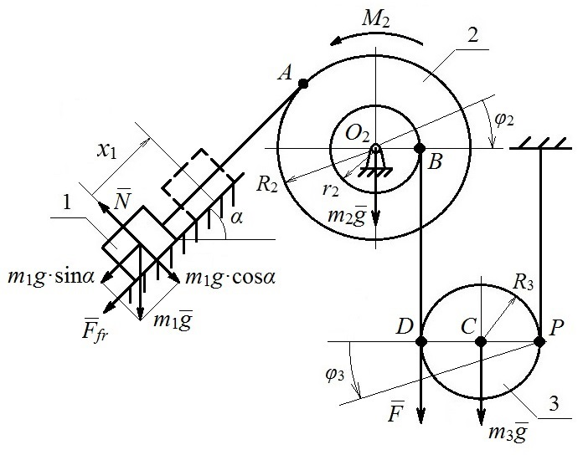
 | Fig. 2 Calculation scheme
Apply the theorem of the change in the kinetic energy of a system (1).
$T-T_{0}=\sum{A_{i}^{E}}+\sum{A_{i}^{I}}$, (1)
where T and Т₀ are kinetic energies of the system in initial and current positions, respectively, $\sum{A_{i}^{E}}$ and $\sum{A_{i}^{I}}$ are sums of works done by external and internal forces, which are applied to the system during the translation from the initial to current position, respectively.
For the given system, which consists of absolutely rigid bodies that are connected via inextensible strings, the sum of works done by internal forces $\sum{A_{i}^{I}}=0$.
It is also given that the system is in equilibrium at the initial position, hence Т₀ = 0. Then, formula (1) can be transformed into
$T=\sum{A_{i}^{E}}$. (2)
Construct a calculation scheme (fig. 2) in order to determine the kinetic energy of the system T and the sum of works done by external forces $\sum{A_{i}^{E}}$. Indicate the given system in a current position in the figure using a dashed line. Indicate additional points A, B, C, D, P, O₂ and directions of motion of bodies 2 and 3. Also, indicate all external forces that are applied to the system, such as forces of gravity of bodies m₁g, m₂g, m₃g, force of friction of body 1 on the inclined surface F_{fr}, and normal reaction of the surface N.
Construct kinematic dependencies between velocities and translations of points in the system. Express velocities and translations of points through the parameters of body 1 (x₁, v₁).
$x_{1}=φ_{2}∙R_{2}$,
$φ_{2}∙r_{2}=φ_{3}∙2R_{3}$,
from where the following is obtained
$φ_{2}=\frac{x_{1}}{R_{2}}$, (3)
$φ_{3}=\frac{φ_{2}∙r_{2}}{2R_{3}}=\frac{x_{1}∙r_{2}}{2R_{2}∙R_{3}}$, (4)
$x_{C}=φ_{3}∙R_{3}=\frac{x_{1}∙r_{2}}{2R_{2}}$, (5)
$x_{D}=φ_{3}∙2R_{3}=\frac{x_{1}∙r_{2}}{R_{2}}$. (6)
Respectively,
$ω_{2}=\frac{dφ_{2}}{dt}=\frac{dx_{1}}{dt}∙\frac{1}{R_{2}}=\frac{v_{1}}{R_{2}}$, (7)
$ω_{3}=\frac{dφ_{3}}{dt}=\frac{v_{1}∙r_{2}}{2R_{2}∙R_{3}}$, (8)
$v_{C}=\frac{dx_{C}}{dt}=\frac{v_{1}∙r_{2}}{2R_{2}}$. (9)
Kinetic energy of the system
$T=T_{1}+T_{2}+T_{3}$. (10)
Then, the kinetic energies of bodies considering the dependencies (7-9)
$T_{1}=\frac{m_{1}∙v_{1}^{2}}{2}$, (11)
$T_{2}=\frac{I_{2}∙ω_{2}^{2}}{2}=\frac{m_{2}∙i_{2}^{2}∙{\left(\frac{v_{1}}{R_{2}}\right)}^{2}}{2}$, (12)
$T_{3}=\frac{m_{3}∙v_{C}^{2}}{2}+\frac{I_{3}∙ω_{3}^{2}}{2}=\frac{m_{3}∙{\left(\frac{v_{1}∙r_{2}}{2R_{2}}\right)}^{2}}{2}+\frac{\frac{m_{3}∙i_{3}^{2}}{2}∙{\left(\frac{v_{1}∙r_{2}}{2R_{2}∙R_{3}}\right)}^{2}}{2}$, (13)
where moments of inertia of bodies 2 and 3 are as follows
$I_{2}=m_{2}∙i_{2}^{2}=20∙{0.75}^{2}=11.25 (kg∙m^{2})$,
$I_{3}=\frac{m_{3}∙i_{3}^{2}}{2}=\frac{30∙{0.75}^{2}}{2}=8.438 (kg∙m^{2})$.
Substitute (11-13) in (10)
$$T=\frac{m_{1}∙v_{1}^{2}}{2}+\frac{m_{2}∙i_{2}^{2}∙{\left(\frac{v_{1}}{R_{2}}\right)}^{2}}{2}+\frac{m_{3}∙{\left(\frac{v_{1}∙r_{2}}{2R_{2}}\right)}^{2}}{2}+\frac{\frac{m_{3}∙i_{3}^{2}}{2}∙{\left(\frac{v_{1}∙r_{2}}{2R_{2}∙R_{3}}\right)}^{2}}{2}$$
and take the common multiplier $\frac{v_{1}^{2}}{2}$ outside the parenthesis
$T=\frac{v_{1}^{2}}{2}\left[m_{1}+m_{2}∙i_{2}^{2}∙{\left(\frac{1}{R_{2}}\right)}^{2}+ m_{3}∙{\left(\frac{r_{2}}{2R_{2}}\right)}^{2}+\frac{m_{3}∙i_{3}^{2}}{2}∙{\left(\frac{r_{2}}{2R_{2}∙R_{3}}\right)}^{2}\right]=\frac{v_{1}^{2}}{2}∙M_{red}$ (14)
where the quantity in parenthesis $M_{red}=24.06$ is reduced mass, kg.
Determine the work done by external forces
$\sum{A_{i}^{E}}=A\left(m_{1}g\right)+A\left(F_{fr}\right)+A\left(N\right)+A\left(m_{2}g\right)+A\left(M_{2}\right)+A\left(m_{3}g\right)+A\left(F\right)$. (15)
The work done by force of gravity of body 1 is determined as a product of a magnitude of the force of gravity, translation of a point, to which it is applied (in this case translation of body 1) and a cosine of the angle between the direction of force and the direction of translation of body 1. Determine the works done by other forces and moments of forces analogically, while considering the dependencies (3-6).
$$A\left(m_{1}g\right)=m_{1}g∙x_{1}∙\cos\left(m_{1}g; x_{1}\right)=m_{1}g∙x_{1}∙\cos\left(90°+α\right)=$$
$=10∙9.8∙x_{1}∙\left(-0.707\right)=-69.29∙x_{1} (J)$.
Work done by the force of friction
$$A\left(F_{fr}\right)=F_{fr}∙x_{1}∙\cos\left(F_{fr}; x_{1}\right)=F_{fr}∙x_{1}∙\cos{180°}=$$
$=6.93∙x_{1}∙\left(-1\right)=- 6.93∙x_{1} (J)$,
where $F_{fr}=N∙f=m_{1}g∙\cos{α}∙f=10∙9.8∙0.707∙0.1=6.93 (N)$,
and $N=m_{1}g∙\cos{α}$ from the equation of equilibrium on the axis, which is perpendicular to the surface.
Work done by a normal reaction of the surface
$A\left(N\right)=N∙x_{1}∙\cos\left(N; x_{1}\right)=N∙x_{1}∙\cos{90°}=0$.
The work done by force of gravity of body 2 is equal to 0 because the translation of point О₂ is equal to 0.
$A\left(m_{2}g\right)=m_{2}g∙x_{O_{2}}∙\cos\left(m_{2}g; x_{O_{2}}\right)=0$.
The work done by the moment of force М₂
$A\left(M_{2}\right)=M_{2}∙φ_{2}∙\cos\left(M_{2}; φ_{2}\right)=M_{2}∙\frac{x_{1}}{R_{2}}∙\cos{180°}=$
$=10∙\frac{x_{1}}{1}∙\left(-1\right)=-10∙x_{1} (J)$.
The work done by force of gravity of body 3
$$A\left(m_{3}g\right)=m_{3}g∙x_{С}∙\cos\left(m_{3}g; x_{С}\right)=m_{3}g∙\frac{x_{1}∙r_{2}}{2R_{2}}∙\cos{0°}=$$
$=30∙9.8∙\frac{x_{1}∙0.5}{2∙1}∙1=73.5∙x_{1} (J)$.
The work done by force F
$$A\left(F\right)=F∙x_{D}∙\cos\left(F; x_{D}\right)=F∙\frac{x_{1}∙r_{2}}{R_{2}}∙\cos{0°}=$$
$$=50∙\frac{x_{1}∙0.5}{1}∙1=25∙x_{1} (J).$$
Substitute works done by all forces in (15)
$$\sum{A_{i}^{E}}=m_{1}g∙x_{1}∙\cos\left(90°+α\right)+F_{fr}∙x_{1}∙\cos{180°}+$$
$+M_{2}∙\frac{x_{1}}{R_{2}}∙\cos{180°}+m_{3}g∙\frac{x_{1}∙r_{2}}{2R_{2}}∙\cos{0°}+F∙\frac{x_{1}∙r_{2}}{R_{2}}∙\cos{0°}$,
take the common multiplier x₁ outside the parenthesis
$$\sum{A_{i}^{E}}=x_{1}∙[m_{1}g∙\cos\left(90°+α\right)+F_{fr}∙\cos{180°}+$$
$$+M_{2}∙\frac{1}{R_{2}}∙\cos{180°}+m_{3}g∙\frac{r_{2}}{2R_{2}}∙\cos{0°}+F∙\frac{r_{2}}{R_{2}}∙\cos{0°}]=$$
$=x_{1}∙[-69.29- 6.93-10+73.5+25]=x_{1}∙F_{red}$, (16)
where $F_{red}=12.28$ is reduced force, N.
Equate (14) and (16), which is the transformed expression (2)
$\frac{v_{1}^{2}}{2}∙M_{red}=x_{1}∙F_{red}$, (17)
from where the following is obtained
$v_{1}=\sqrt{\frac{2∙x_{1}∙F_{red}}{M_{red}}}$,
substitute x₁ = 1 m from the initial data and obtain
$v_{1}=\sqrt{\frac{2∙1∙12.28}{24.06}}=1.01 (m/s)$.
Differentiate (17) with respect to the time parameter
$\frac{d\left(\frac{v_{1}^{2}}{2}∙M_{red}\right)}{dt}=\frac{d\left(x_{1}∙F_{red}\right)}{dt}$,
$\frac{1}{2}∙2v_{1}∙a_{1}∙M_{red}=v_{1}∙F_{red}$,
$a_{1}=\frac{F_{red}}{M_{red}}=\frac{12.28}{24.06}=0.51 (m/s^{2})$.
Answer: v₁ = 1.01 m/s, a₁ = 0.51 m/s².

