ТМ-9 part 1
Determine laws of motion of bodies 2 and 3 (fig. 1), absolute velocity and acceleration of point М. It is known, that the law of motion of body 1 is x₁ = 5t², m; external radius of body 2 is R₂ = 1 m, internal radius of body 2 is r₂ = 0.5 m, and a radius of body 3 is R₃ = 0.75 m, time parameter is t = 1 s.
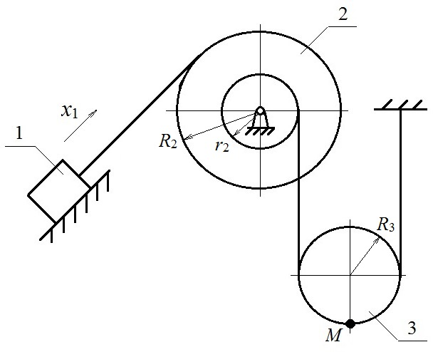
Fig. 1 Initial scheme

Solution
Given:  x₁ = 5t², m  R₂ = 1 m  r₂ = 0.5 m  R₃ = 0.75 m  t = 1 s  Find:  φ₂, φ_{3,} v_{M,} a_{M} | 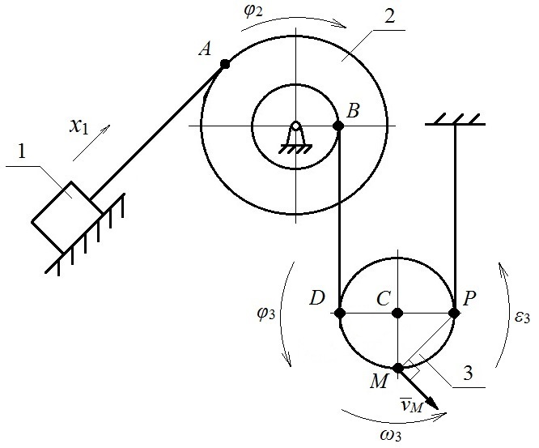
 | Fig. 2 Calculation scheme
Construct a calculation scheme (fig. 2). Place additional points A, B, C, D, P on it, and directions of motion of bodies 2 and 3, directions of angular velocity ω₃ and angular acceleration ε₃ of body 3, and a vector of absolute velocity v_{M}.
Body 1 moves linearly, body 2 rotates, and body 3 performs plane motion. Body 1 and point A are connected through an ideal string (the one that doesn’t deform). Points B and D, P and a support are also connected through an ideal string.
Direction of motion of body 1 is given in the initial data. If body 1 moves linearly along an inclined surface and is connected with point A through an ideal string, then body 2 rotates clockwise (designated as φ₂ in fig. 2). Direction of motion of body 3 can be determined analogically. Body 3 rotates counterclockwise (designated as φ₃ in fig. 2).
If a string is ideal, then movement of body 1 is equal to a length of a string, which is wound up on external radius of body 2. Analogically, a length of a string, which is unwound from internal radius of body 2, is equal to a length of a string, which is wound up on radius of body 3. Express string lengths using the angle and radius of rotation.
Determine the equations of kinematic connections
$x_{1}=φ_{2}∙R_{2}$,
$φ_{2}∙r_{2}=φ_{3}∙2R_{3}$.
From where the laws of motion of bodies 2 and 3 are
$φ_{2}=\frac{x_{1}}{R_{2}}=\frac{5t^{2}}{1}=5t^{2}, rad$,
$φ_{3}=\frac{φ_{2}∙r_{2}}{2R_{3}}=\frac{5t^{2}∙0.5}{2∙0.75}=1.67t^{2}, rad$.
Determine angular velocity ω₃ and angular acceleration ε₃ of body 3.
$ω_{3}=\frac{{dφ}_{3}}{dt}=\frac{d(1.67t^{2})}{dt}=3.34t, rad/s$,
$ε_{3}=\frac{{dε}_{3}}{dt}=\frac{d(3.34t)}{dt}=3.34, rad/s^{2}$.
ω₃ and ε₃ are directed counterclockwise since they are positive for a positive t.
Body 3 performs plane motion and is connected with a support through a string. Then a center of rotation (instantaneous center of velocity) of body 3 is point Р.
Determine absolute velocity of point М.
$v_{M}=ω_{3}∙MP=3.34t∙\sqrt{2}∙R_{3}=3.53t, m/s$.
At the moment of time t = 1 s
$v_{M}=3.53∙1=3.53 m/s$.
Absolute acceleration of a body, which performs plane motion, is determined as a vector sum of accelerations of a pole $\overline{a_{C}}$, normal $\overline{a_{MC}^{n}}$, and tangent $\overline{a_{MC}^{τ}}$ accelerations of the considered point around this pole. The pole is the point, acceleration of which is known or is easy to calculate. Define point С as a pole since it is a center of mass of body 3 and moves linearly.
$$\overline{a_{M}}=\overline{a_{C}}+\overline{a_{MC}^{n}}+\overline{a_{MC}^{τ}}$$
Determine acceleration of point С
$x_{C}=φ_{3}∙CP=1.67t^{2}∙R_{3}=1.25t^{2}, m$,
$v_{C}=\frac{{dx}_{C}}{dt}=\frac{d(1.25t^{2})}{dt}=2.5t, m/s$,
$a_{C}=\frac{{dv}_{C}}{dt}=\frac{d(2.5t)}{dt}=2.5 m/s^{2}$.
Determine normal and tangent accelerations of point М relatively to the pole С at the moment of time t = 1 s
$a_{MC}^{n}=ω_{3}^{2}∙MC={\left(3.34t\right)}^{2}∙R_{3}=8.37 (m/s^{2})$,
$a_{MC}^{τ}=ε_{3}∙MC=3.34∙R_{3}=2.51 (m/s^{2})$.
In order to determine absolute acceleration of point М, project the vectors of determined accelerations on coordinate axes x and y (fig. 3). Note that normal acceleration $\overline{a_{MC}^{n}}$ is directed from point M to the pole C, and tangent acceleration $\overline{a_{MC}^{τ}}$ is perpendicular to the normal acceleration and is directed along angular acceleration $ε_{3}$.
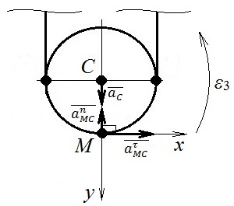
Fig. 3 Acceleration calculation scheme

Then absolute acceleration a_{M} of point М
$$a_{M}=\sqrt{{\left(\sum{a_{ix}}\right)}^{2}+{\left(\sum{a_{iy}}\right)}^{2}}=\sqrt{{\left(a_{MC}^{τ}\right)}^{2}+{\left(a_{C}-a_{MC}^{n}\right)}^{2}}==\sqrt{{2.51}^{2}+{\left(2.5-8.37\right)}^{2}}=6.38 (m/s^{2}).$$

Answer: $φ_{2}=5t^{2}, rad$, $φ_{3}=1.67t^{2}, rad$, $v_{M}=3.53 m/s$, $a_{M}=6.38 m/s^{2}$.

